**The Battle of Neighborhoods**

**Capstone Project- IBM Data Science Professional Certification**

**Opening a new Indian Restaurant**

**Introduction**

New York City's demographics show that it is a large and ethnically diverse metropolis. It is the largest city in the United States with a long history of international immigration. New York City was home to nearly 8.5 million people in 2014, accounting for over 40% of the population of New York State and a slightly lower percentage of the New York metropolitan area, home to approximately 23.6 million. Over the last decade the city has been growing faster than the region.

The New York region continues to be by far the leading metropolitan gateway for legal immigrants admitted into the United States. Throughout its history, New York City has been a major point of entry for immigrants; the term "melting pot" was coined to describe densely populated immigrant neighborhoods on the Lower East Side.

As many as 800 languages are spoken in New York, making it the most linguistically diverse city in the world. English remains the most widely spoken language, although there are areas in the outer boroughs in which up to 25% of people speak English as an alternate language, and/or have limited or no English language fluency. English is least spoken in neighborhoods such as Flushing, Sunset Park, and Corona. NYC brings tourists in droves for its world-class museums, monuments, shopping, and theater. But it is also a city in which eating is often not something you do between activities, it is the activity.

New York has one of the most competitive and diverse restaurant scenes anywhere in the world—one study from earlier in the decade found that 80 percent of restaurants in New York close in the first five years (though that also means new and exciting eateries are opening constantly). Whether you want a three Michelin star tasting menu, a big plate of comfort food or just the best freakin' slice of pizza you've ever had in your life, you can find it in New York City. There are many resturants in New york City, each beloning to different categories like Chinese , Indian , French etc.

***reference:***[***https://www.cntraveler.com/gallery/best-restaurants-in-new-york-city***](https://www.cntraveler.com/gallery/best-restaurants-in-new-york-city)

***reference:***[***https://en.wikipedia.org/wiki/Demographics_of_New_York_City***](https://en.wikipedia.org/wiki/Demographics_of_New_York_City)

**A description of the problem**

In this project we will list and visualize all major parts of New York City that has great indian resturants so as to decide the place one can open an Indian food restaurant considering the concentration of the restaurants.

**For this project we need the following data :**

New York City data that contains list Boroughs, Neighborhoods along with their latitude and longitude.

* Data source : <https://cocl.us/new_york_dataset>
* Description : This data set contains the required information. And we will use this data set to explore various neighborhoods of new york city.

Indian resturants in each neighborhood of new york city.

* Data source : Fousquare API
* Description : By using this api we will get all the venues in each neighborhood. We can filter these venues to get only indian resturants. GeoSpace data
* Data source : <https://data.cityofnewyork.us/City-Government/Borough-Boundaries/tqmj-j8zm>
* Description : By using this geo space data we will get the New york Borough boundaries that will help us visualize choropleth map.

**Methodology**

* Collect the new york city data from <https://cocl.us/new_york_dataset>
* Using FourSquare API finding all venues for each neighborhood.
* Filter out all venues which are Indian Resturants.
* Find rating , tips and like count for each Indian Resturants using FourSquare API.
* Sorting the data using rating for each resturant.
* Visualize the Ranking of neighborhoods using folium library(python)

**This dataset shall answer the following questions for a person seeking to open a new Indian Restaurant**

* What is best location in New York City for Indian Cuisine ?
* Which areas have potential Indian Resturant Market ?
* Which all areas lack Indian Resturants ?
* Which is the best place to stay if I prefer Indian Cuisine ?

**Libraries needed**

* pandas and numpy for handling data.
* request module for using FourSquare API.
* geopy to get co-ordinates of City of New York.
* folium to visualize the results on a map

**RESULTS-**

1. **Data about NYC**

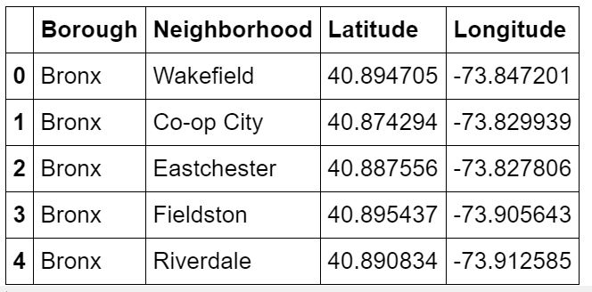

Inference : There are total of 306 different Neighborhoods in New York

1. **number of neighborhoods**

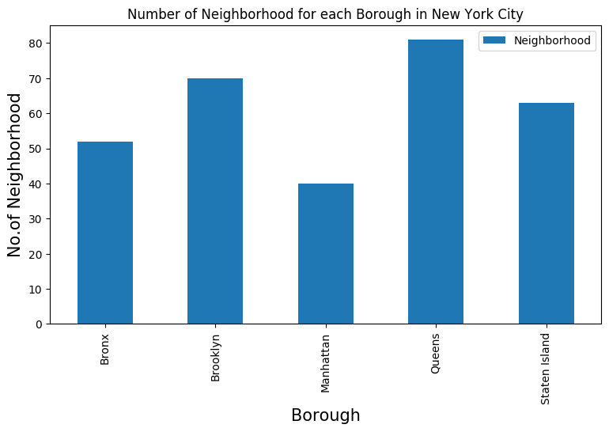

Inference : We see that Queens has highest number of neighborhoods

1. **Indian restaurants for each Neighborhood**

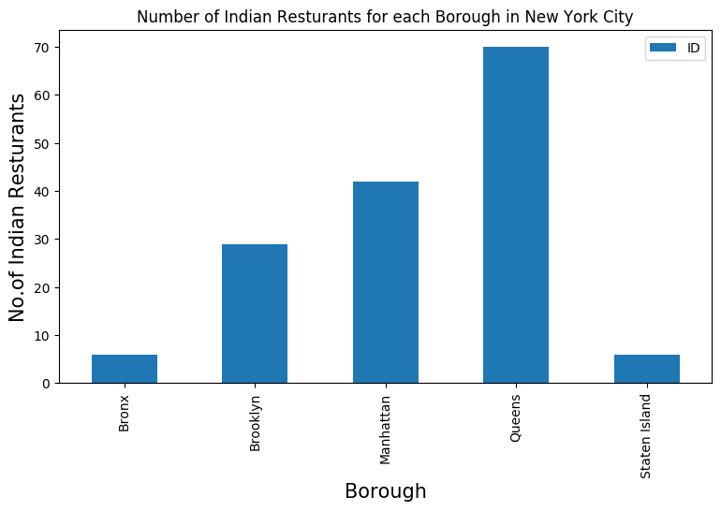

Inference: Queens has the largest number of indian resturants

**Conclusions and Recommendations**

* The best neighborhoods for Indian cuisines are- Astoria(Queens), Blissville(Queens) and Civic Center(Manhattan)
* The highest potential for Indian Restaurant is the market area in Manhattan
* The least average rating of Indian Restaurants is in Staten Island. The reasons could be further investigated.
* For an Indian Cuisine lover Manhattan is the best place to visit and eat
* If one wants to open a new Indian cuisine restaurant, Manhattan is best choice.
* Other options to be considered are- Astoria(Queens) and Blissville(Queens)

**Limitations**

* The potential is estimated on the basis of ratings of restaurants which is based on the judgement of foursquare users.
* The accuracy of data depends on the data provided by FourSquare